Lab 02

BASIC LOGIC GATES

Student ID: 10303, 10577, 09850
Name: Sualeh, Wasiq, Hassan (G6)

Objective
After performing this lab, students should be able to:
- Measure voltage using Digital Multimeter (DMM).
- Verify the behavior of logic gates using the Truth Table (AND, OR, NOT and NOR gates) on breadboard using DMM
- Utilize Datasheet to get familiarized with digital integrated circuits and the internal IC gate level structure.

2.2 Apparatus / Equipment

    - Logic Circuits are basically electric circuits which implement certain logical function. Before we div Adjustable Direct Current (DC) Power supply.
    - Digital Multi Meter (DMM).
    - IC type 7408 AND gate.
    - Light Emitting Diode (LED)
    - Resistors (330 Ohm)
    - Slide switches.
    - IC type 7404 NOT gate.
    - IC type 7402 NOR gate.

2.3 Warm-up Task
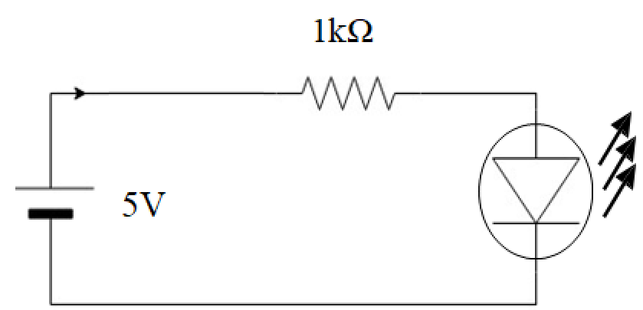
Figure 2.0: Schematic Diagram for testing voltage measurement

Build the circuit diagram as shown in Figure 2.0 and perform following experiments and record the readings in Table 2.0.
- Power-up circuit with 5-V from power supply and measure voltage across resistor.
- Swap the positions of LED and resistor and measure the voltage across resistor.
- Add one more LED, and measure the voltage across resistor.
Table 2.0
Step | Reading (Volts)
1 | 3.3V
2 | 3.3V
3 | 1.6V

Explain observations and reading in your own words below:

When there was only one led, the voltage across resistor was 3.3V, when we swap the places of led and resistor, no voltage changed across resistor. But when we added another led in series to our first LED, the voltage drop on resistor was almost by half.

  - Reading Datasheet

Task a
In this task you are required to read the datasheet and get familiarized with internal gate level structure of following ICs.
- AND gate IC 7408
- NOT gate IC 7404
- NOR gate IC 7402

Using datasheet find out the recommended operating supply voltage for IC 7408
The operation voltage of 7408 is 2.0V to 6.0V

  - AND Logic Gate

The AND logic gate is a basic digital logic gate that implements logical conjunction; it behaves according to the truth table given in Table 2.1. A HIGH output (logic 1) results only if both the inputs to the AND gate are HIGH. If neither or only one input to the AND gate is HIGH, a LOW (logic 0) output results. In other words, the AND function effectively finds the minimum between two binary digits. Therefore, the output is always logic 0 except when all the inputs are HIGH. The logic symbol or Boolean expression for an AND gate is the dot sign “·”. It describes the AND operation on two inputs. In the expression below, A and B are the inputs and Y is the output.

$$Y =A · B$$

Three input AND operation can be performed with the sample expression shown below; where A, B and C are inputs, and Y is the output which is always a logic 0 except when all the inputs are HIGH.
$$Y = A · B · C$$

Task b
- Design Schematic
- Figure 2.1 shows the internal diagram of 7408 AND gate taken from datasheet.
- Figure 2.2 shows the schematic diagram for this experiment.
- The truth table for an AND gate with two inputs is given in Table 2.1.
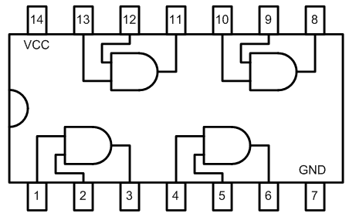 | 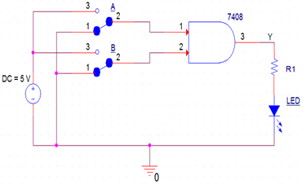
Figure 2.1 - 7408 AND logic gate IC | Figure 2.2 - Design schematic of a two-input AND gate.

Table 2.1 - Truth table for the AND gate.
Input (A) | Input (B) | Output (Y)
0 | 0 | 0
0 | 1 | 0
1 | 0 | 0
1 | 1 | 1

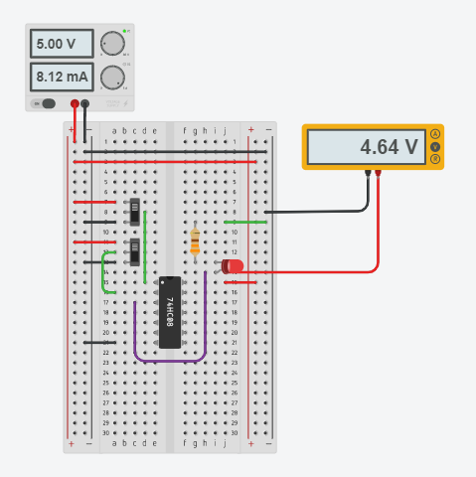

Figure 2.3 - 2 Input AND gate circuit implementation
- Procedure and observations
- Place the breadboard on the activity area of your workstation
- Fix the IC on the breadboard.
- Connect a wire to the voltage source, power supply (Vcc = 5 V), whose other end is connected to last pin of the IC (14th pin from the notch).
- Connect the ground pin of the IC (7th pin from the notch) to the negative terminal provided by the DC power supply.
- Provide the input at any one gate of the IC i.e., 1st, 2nd, 3rd or 4th gate by using connecting wires and slide switch. In accordance to the IC provided, 5V corresponds to logic high and 0V corresponds to logic low.
- Connect output pins to an LED through a resistor.
- Connect voltmeters at input and output pins of the IC.
- Switch on the power supply.
- If LED glows then output is true, if it does not glow, the output is false, which is numerically denoted as logic 1 (high) and logic 0 (low) respectively. Test the truth table provided in Table 2.
- Complete Table 2.1 with two inputs.
- From the given ICs, realize a 3-input AND gate. Record observations in Table 2.2.
Hint: Refer to Boolean expression for the definition of three input AND gate in section 2.5.

 | Make sure that the power supply is set to 5V and turn it on only when the connections are verified.

 | When working on physical circuit, use DMM to verify the connections and troubleshooting.

Table 2.1 - Data Table for 2-Input AND Gate
Input |  |  |  | Output
A  (Logic) | B  (Logic) | A (Volts) | B (Volts) | Y  (Logic) | Y (Volts)
0 | 0 | 0 | 0.018 | 0 | 0.016
0 | 1 | 0 | 4.95 | 0 | 1.05
1 | 0 | 4.94 | 0 | 0 | 0.2
1 | 1 | 4.95 | 4.95 | 1 | 3.3

Table 2.2 - Data Table for 3-Input AND Gate
Input |  |  |  |  |  | Output
A  (Logic) | B  (Logic) | C  (Logic) | A (Volts) | B (Volts) | C  (Volts) | Y  (Logic) | Y (Volts)
0 | 0 | 0 | 0.07 | 0.07 | 0.08 | 0 | 0.86
0 | 0 | 1 | 0.07 | 0.08 | 4.94 | 0 | 1.03
0 | 1 | 0 | 0.02 | 4.95 | 0.02 | 0 | 0.87
0 | 1 | 1 | 0.04 | 4.95 | 4.95 | 0 | 1.03
1 | 0 | 0 | 4.95 | 0.04 | 0.07 | 0 | 0.9
1 | 0 | 1 | 4.95 | 0.08 | 4.95 | 0 | 1.06
1 | 1 | 0 | 4.95 | 4.95 | 0.006 | 0 | 1.0
1 | 1 | 1 | 4.95 | 4.95 | 4.94 | 1 | 2.9

Draw logic diagram of realization of three input AND gate using two input AND gates and any other gate (if necessary).
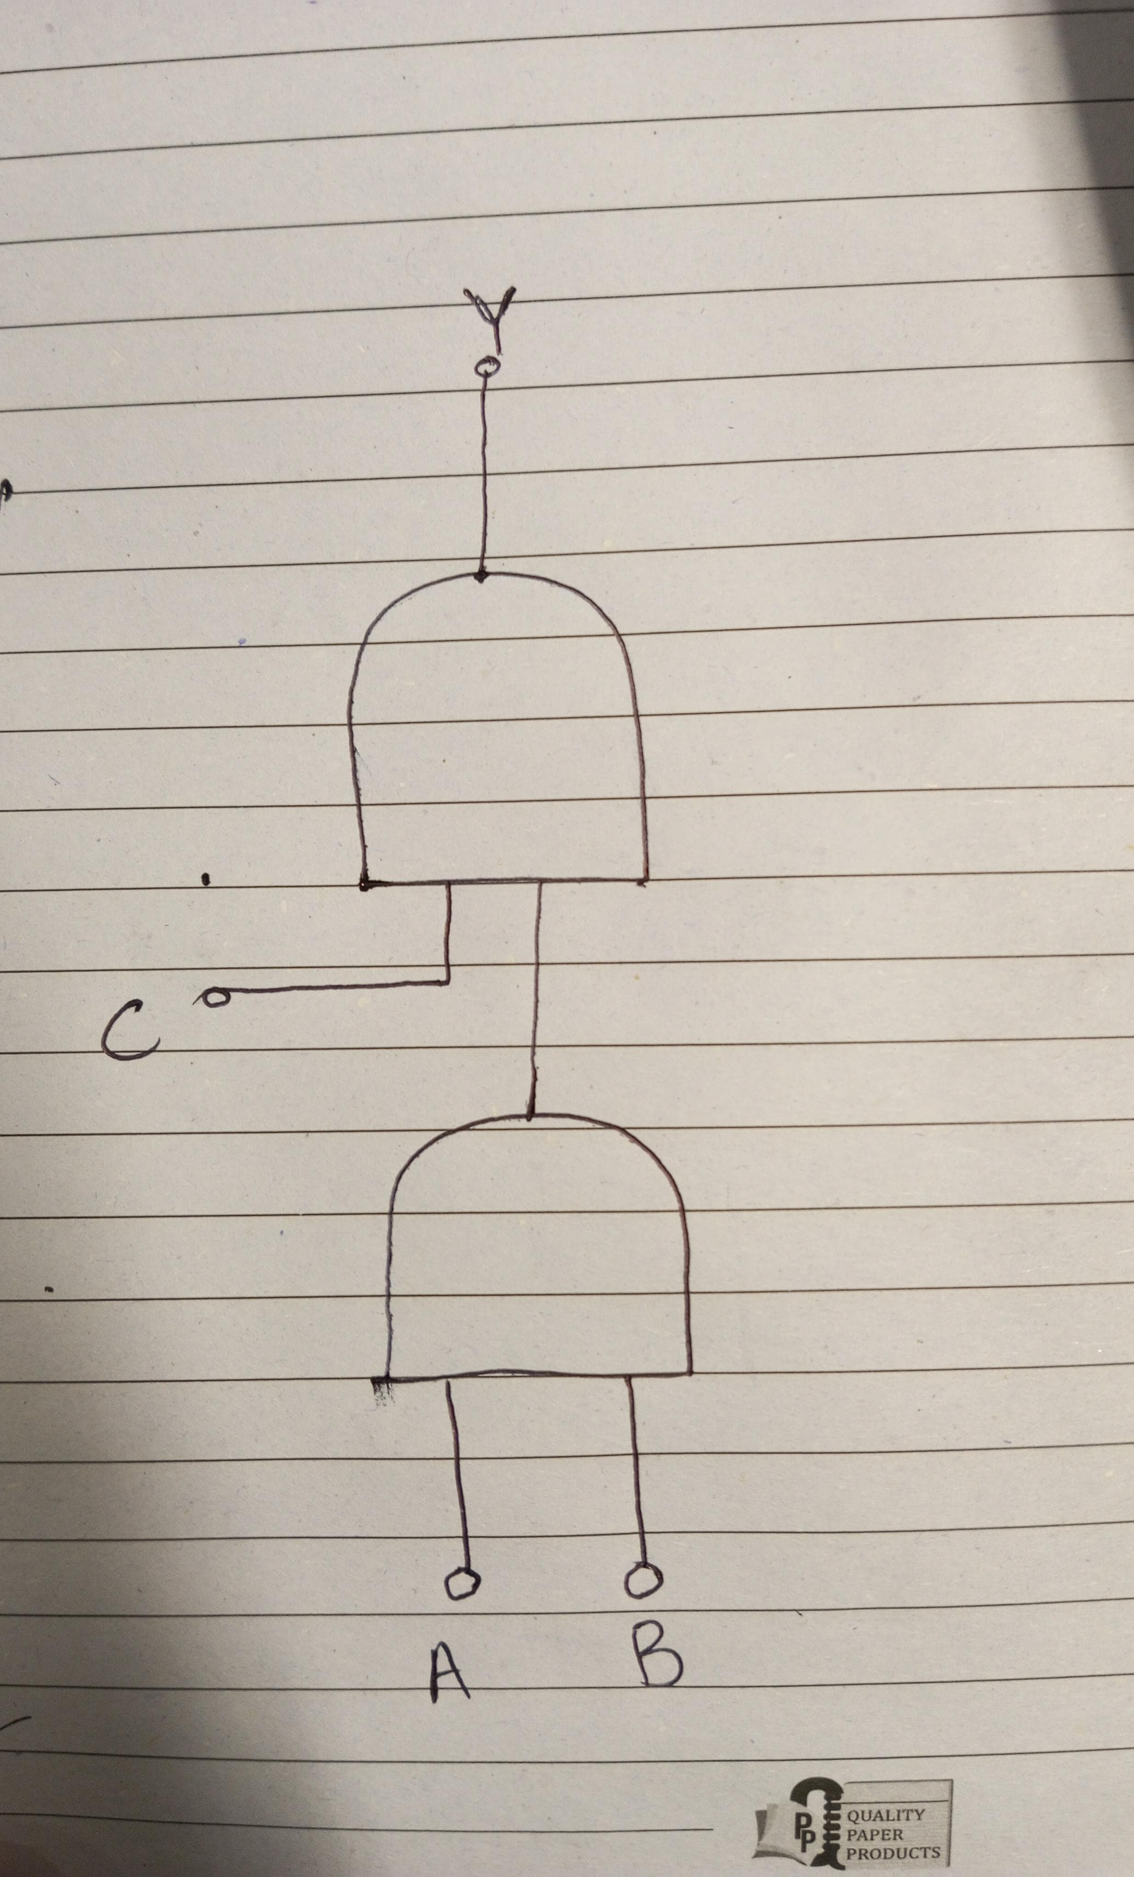

  - NOT Logic Gate

A NOT gate (also called inverter) is another type of logic gate. It takes one input signal and produces an inverted output signal. In logic, there are usually two states, logic 0 and logic 1. The NOT gate sends logic 1 as output, if it receives logic 0 as input. Alternatively, if it receives logic 1 as input, it sends logic 0 as output. Generally, below 0.5 V is logic 0, and 4 V to 5 V is logic 1. Several inverters are packaged in an integrated circuit. The mathematical expression is:
$$Y=\overline{A}$$

Task c
- Design Schematic
- The truth table for a NOT gate with two inputs is given in Table 2.3.
- Figure 2.5 shows the schematic diagram for this experiment.

Table 2.3 - Truth table for the NOT gate.
Input (A) | Output (Y)
0 | 1
1 | 0

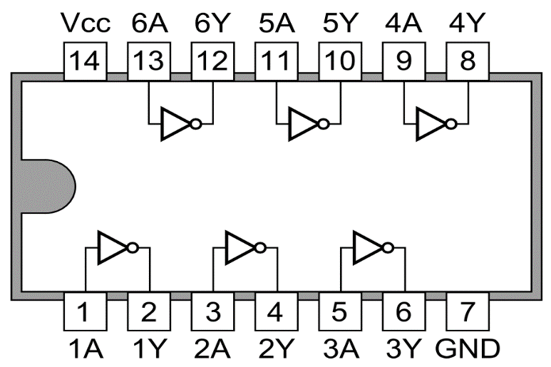 | 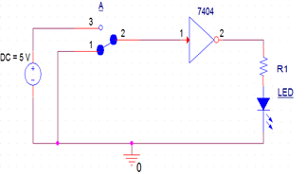
Figure 2.4 - 7404 NOT logic gate IC. | Figure 2.5 - Schematic of NOT gate
- Procedure and observations

- Place the breadboard on the activity area of your sheet.
- Drag and fix the IC which is under observation on the half separator line of breadboard, so there are no short connections.
- Connect a wire to the voltage source, power supply (Vcc = 5 V), whose other end is connected to last pin of the IC (14th pin from the notch).
- Connect the ground pin of the IC (7th pin from the notch) to the negative terminal provided by the DC power supply.
- Provide the input to any gate of the IC i.e., 1st, 2nd, 3rd, 4th, 5th or 6th, by using connecting wires and slide switch. In accordance to the IC provided, 5V corresponds to logic high and 0V corresponds to logic low.
- Connect output pin to an LED through a resistor.
- Connect voltmeter to input and output pins of the IC.
- Switch on the power supply.
- If LED glows then output is true, if it does not glow, the output is false, which is numerically denoted as logic 1 (high) and logic 0 (low) respectively. Test the truth table provided in Table 2.3.
- Complete Table 2.4.
Table 2.4 - Data Table for NOT Gate.
Input |  | Output
A  (Logic) | A  (Volts) | Y  (Logic) | Y  (Volts)
0 | 0 | 1 | 3.6
1 | 5.2 | 0 | 0.13

  - NOR Logic Gate

The logic NOR gate (Not OR) gate is a combination of the digital logic OR gate with that of an inverter or NOT gate connected together in series. The NOR gate has an output that is normally at logic 0 and only goes logic 0 to logic 1, when all of its inputs are at logic 0. The Logic NOR Gate is the reverse or “complementary” form of the OR gate.

The Boolean expression for a logic NOR gate is denoted by a plus sign, (+) with an over line on the expression to signify the NOT or logical negation of the NOR gate. Combining the two operations results in:
$$Y = \overline{A + B}$$

For a three-input NOR gate, the expression would be as below,

$$Y = \overline{A + B + C}$$

Task d
- Design Schematic
- The truth table for an NOR gate with two inputs is given in Table 2.5.
- Figure 2.7 shows the schematic diagrams for this experiment.

Table 2.5 - Truth table for NOR Gate.
Input (A) | Input (B) | Output (Y)
0 | 0 | 1
0 | 1 | 0
1 | 0 | 0
1 | 1 | 0

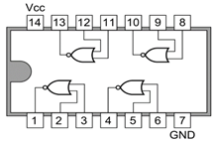 | 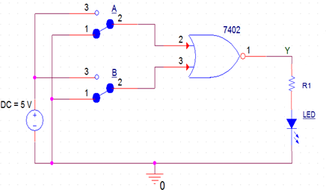
Figure 2.6 - 7402 NOR logic gate IC. | Figure 2.7 - Schematic of NOR gate
- Procedure and observations

From this task onwards, you are expected to make a neat and clean circuit, using short wires, no jumps and neat connections, you may checkout the rubrics for circuit layout marks distribution.

- Place the breadboard on your workstation.
- Drag and fix the IC which is under observation on the half separator line of breadboard, so there are no short connections.
- Connect a wire to the voltage source power supply (Vcc = 5 V) whose another end is connected to last pin of the IC (14th pin from the notch).
- Connect the ground pin of the IC (7th pin from the notch) to the negative terminal of the DC power supply.
- Provide the input at any one gate of the IC i.e., 1st, 2nd, 3rd or 4th gate by using connecting wires and slide switch. In accordance to the IC provided, 5V corresponds to logic high and 0V corresponds to logic low.
- Connect output pins to an LED through a resistor.
- Connect voltmeter probes to input and output pins of the IC.
- Switch on the power supply.
- If LED glows then output is true, if it does not glow, the output is false, which is numerically denoted as logic 1 (high) and logic 0 (low) respectively. Test the truth table provided in Table 2.5.
- Complete Table 2.6 with two inputs.

Table 2.6 - Data Table for 2-Input NOR Gate
Input |  |  |  | Output
A  (Logic) | B  (Logic) | A (Volts) | B (Volts) | Y  (Logic) | Y (Volts)
0 | 0 | 0 | 0 | 1 | 4.8
0 | 1 | 0 | 5.2 | 0 | 0.004
1 | 0 | 5.2 | 0 | 0 | 0.005
1 | 1 | 5.2 | 5.2 | 0 | 0

Table 2.7 - Data Table for 3-Input NOR Gate
Input |  |  | Output
A  (Logic) | B  (Logic) | C  (Logic) | Y  (Logic)
0 | 0 | 0 | 1
0 | 0 | 1 | 0
0 | 1 | 0 | 0
0 | 1 | 1 | 0
1 | 0 | 0 | 0
1 | 0 | 1 | 0
1 | 1 | 0 | 0
1 | 1 | 1 | 0

Draw logic diagram of realization of three input NOR gate using two input NOR gate and any other gate (if necessary). And Fill table 2.7 for three input NOR Gate. Show your answer to the RA.

Hint: Refer to Boolean expression for the definition of three input NOR gate in section 2.7.

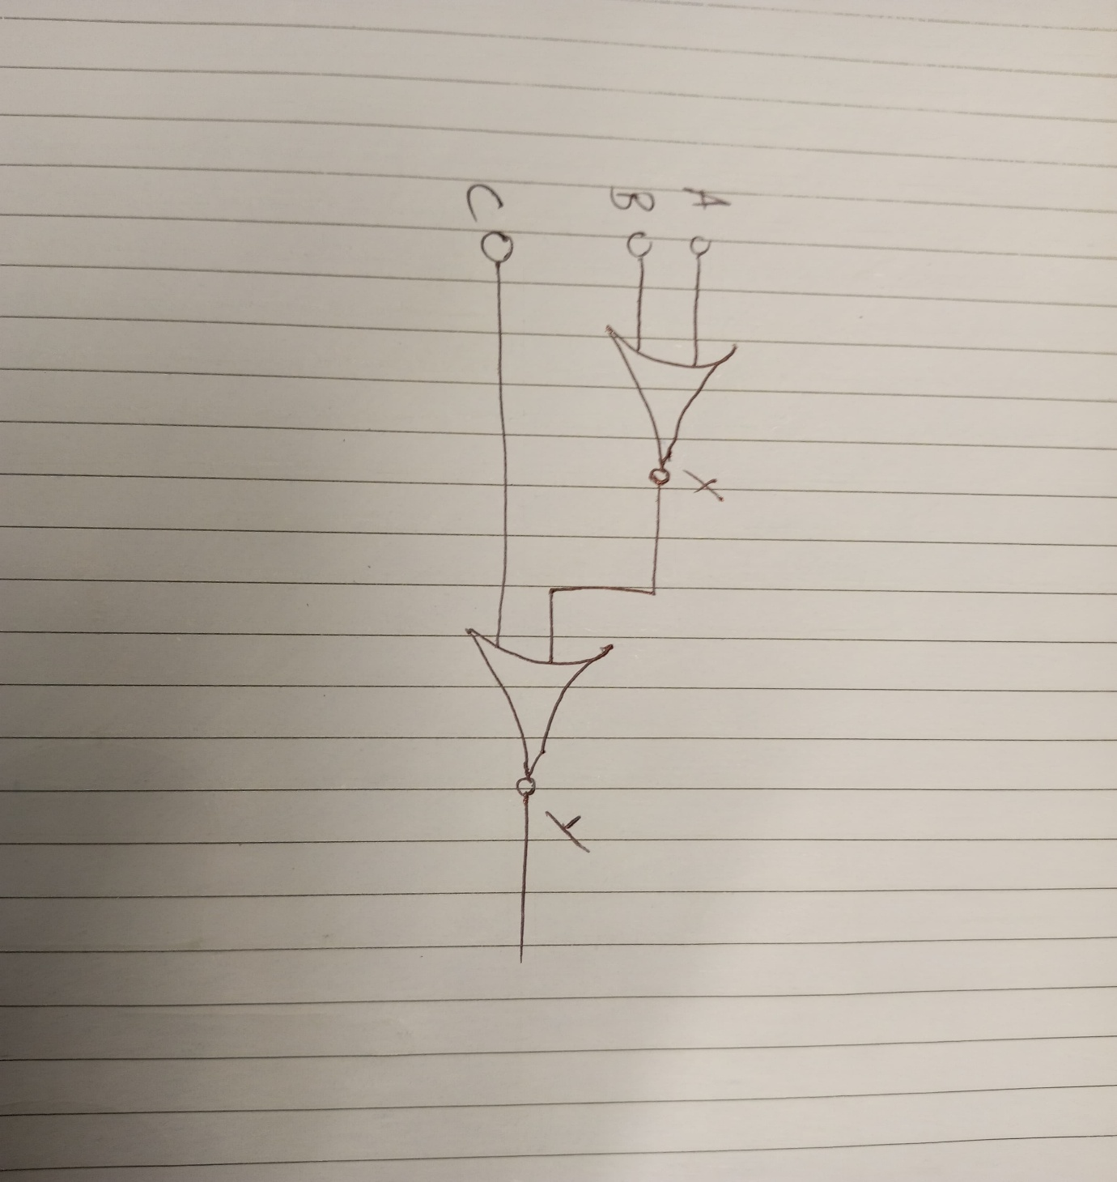

Exercise

- Search the Datasheet of IC 74HC00. Provide its pin configuration and voltage levels for high and low Logic.
PIN Configuration:
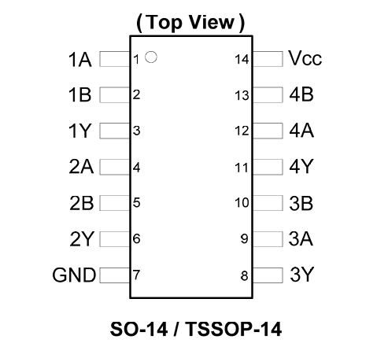
Pins 1, 2, 4, 5, 9, 10, 12, and 13: Inputs for the four NAND gates.
Pins 3, 6, 8, and 11: Outputs for the four NAND gates.
Pin 7: Ground (GND).
Pin 14: Supply Voltage (Vcc).

Voltage levels:
The device is designed for operation with a power supply range of 2.0V to 6.0V.

- If we were to build a truth table for a 16-input AND gate, how many different combinations of inputs would we have? Explain.

ANS. For a single binary input we would have two values either 1 or 0. For 2 inputs we would have four values (00, 01, 11, 10) i.e. 2²=4. For 16 different inputs the value will be 2¹⁶=65,536. The truth table for a 16-input AND gate would have 65,536 rows, representing all possible combinations of the 16 inputs.

- An electronic system will only operate if three switches R, S and T are correctly set. An output signal (X = 1) will occur if R and S are both in the ON position or if R is in the OFF position, and S and T are both in the ON position. Design a logic circuit to represent the above situation, and draw the truth table.
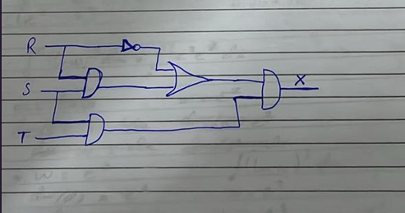

R | S | T | R_{NOT} | R.S=U | U+R_{NOT}=V | S.T=W | W.V=X
0 | 0 | 0 | 1 | 0 | 1 | 0 | 0
0 | 0 | 1 | 1 | 0 | 1 | 0 | 0
0 | 1 | 0 | 1 | 0 | 1 | 0 | 0
0 | 1 | 1 | 1 | 0 | 1 | 1 | 1
1 | 0 | 0 | 0 | 0 | 0 | 0 | 0
1 | 0 | 1 | 0 | 0 | 0 | 0 | 0
1 | 1 | 0 | 1 | 1 | 1 | 0 | 0
1 | 1 | 1 | 1 | 1 | 1 | 1 | 1

- Develop a truth table for the circuit and determine the logic gate.

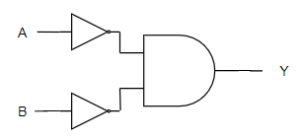 | 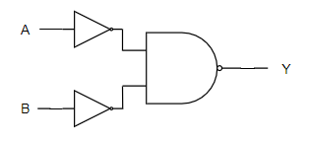
Circuit 1  The logic gate is NAND, as when both the inputs are 0, the output turns out to be 1. | Circuit 2  The logic gate is AND, as when both the inputs are 1, the output is 1.
  A | B | Y
  0 | 0 | 1
  1 | 0 | 0
  0 | 1 | 0
  1 | 1 | 0
  A | B | Y
  0 | 0 | 0
  1 | 0 | 1
  0 | 1 | 1
  1 | 1 | 1

Assessment Rubric Lab 02
Basic Logic Gates

Student ID:
Name:

Marks Distribution:

 | Task No. | LR1  Circuit Layout | LR4  Data Collection |  | LR9  Report
In - Lab | Warm-up | - |  | - | /05
In - Lab | Task a | - |  | /05 | -
In - Lab | Task b | /10 |  | /10 | -
In - Lab | Task c | /05 |  | /05 | -
In - Lab | Task d | /15 |  | /05 | /10
Post - Lab |  |  |  |  | /20
Total = /100 |  | /30 |  | /25 | /35
CLO Mapping |  | CLO 1 |  | CLO 1 | CLO 4

Affective Domain Rubric |  | Points | CLO Mapped
AR 7 | Report Submission and Viva/Performance | /10 | CLO 4

CLO | Total Points | Points Obtained
1 | 55
4 | 45
Total | 100

For description of different levels of the mapped rubrics, please refer to the provided Lab Evaluation Assessment Rubrics and Affective Domain Assessment Rubrics.

Lab Evaluation Assessment Rubrics

# | Assessment Elements | Level 1: Unsatisfactory Points 0-1 | Level 2: Developing  Points 2 | Level 3: Good  Points 3 | Level 4: Exemplary  Points 4
LR1 | Circuit Layout | Connections between circuit components are mostly wrong. Circuit layout is cluttered.  Needs guidance to make correct equipment/ component connections. | Few of the connections made between circuit components are wrong. Circuit layout is not neat and clean as per standards. | Circuit layout and connections are correct but not all connections are neat and clean as per standards. | Neat, clean and correct connections of all the circuit components/ equipment are made as per standard circuit diagram.
LR3 | Troubleshooting | Unable to identify the fault/minimal effort shown in troubleshooting. | Able to identify the fault but unable to remove it. | Able to identify the fault but partially removes it. | Able to identify the fault and takes necessary steps and actions to correct it.
LR5 | Results & Plots | Figures/ graphs / tables are not developed or are poorly constructed with erroneous results. Titles, captions, units are not mentioned.  Data is presented in an obscure manner. | Figures, graphs and tables are drawn but contain errors. Titles, captions, units are not accurate. Data presentation is not too clear. | All figures, graphs, tables are correctly drawn but contain minor errors or some of the details are missing. | Figures / graphs / tables are correctly drawn and appropriate titles/captions and proper units are mentioned. Data presentation is systematic.
LR7 | Viva | Response shows a complete lack of understanding of the assigned / completed task | Response shows shallow understanding of the assigned task | Response shows substantial understanding of the assigned task | Response shows complete understanding of the completed task. The student is able to explain all the related concepts.
LR10 | Analysis | Results are not interpreted or are analyzed incorrectly. | Analysis of the obtained results is incomplete.  Conclusions are not drawn. | Results are analyzed and concluded but are not well explained and justification is not provided with the help of reasoning. | Results are well analyzed supported with reasons. Good comparison is made between the theoretical and experimental results with correct and useful conclusion.
LR11 | Design | Proposed design is unsubstantiated or does not satisfy most of given constraints. The breakdown of system into features is incomplete and still at lower resolution. | Justification for proposed design is weak, and it only satisfies some constraints. The breakdown of system is missing some features and resolution is not appropriate at some places. | Proposed design is substantiated, preferably through proper analysis, and satisfies most given constraints. The breakdown of system into features seems complete, but resolution is not appropriate at some places. | Proposed design is substantiated, preferably through proper analysis, and satisfies all given constraints. The breakdown of system into features seems complete and at appropriate resolution, given students' level.

Voltage level is not the operating voltage, it is the low-level and high-level input and output voltages at a certain supply value, in Digital circuits 5V is the Vcc, choose the value nearest to it.

